**Fingerprint Recognition Algorithm**

Biometrics is an emerging field where technology improves our ability to identify a person. The advantage of biometric identification is that each individual has its own physical characteristics that cannot be changed, lost or stolen. Fingerprint recognition is one of the oldest and most popular biometric technology, and it is used in criminal investigations, civilian, commercial applications, and so on. This project aims to develop a complete system for fingerprint recognition through extracting and matching minutiae.

To achieve good minutiae extraction in fingerprints with varying quality, preprocessing in image enhancement and binarization is first applied on fingerprints before they are evaluated. An alignment-based elastic matching algorithm has been developed for minutia matching. This algorithm can find the correspondences between the input minutia pattern and the stored template minutia pattern without resorting to a comprehensive search.

A pattern or “map” of the minutiae is stored in a database as a representation of the fingerprint. In essence, what’s stored in the memory is not the fingerprint itself but a set of key minutiae (see below).

[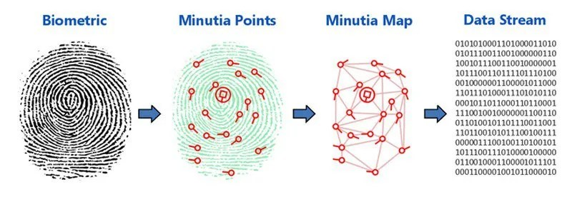](https://i0.wp.com/semiengineering.com/wp-content/uploads/2016/11/fingerprint-sensor-security-fig3.jpg)Source: Engadget (cool3c.com) (<http://bit.ly/1U9LnHz>)

Pre-processing is a very important phase in the algorithm. Indeed, it makes it possible to improve the image to facilitate the task in the second step and to optimize the processing of the image; the different preprocessing phases are presented in the following figure:

References

Last Name, F. M. (Year). Article Title. *Journal Title*, Pages From - To.

Last Name, F. M. (Year). *Book Title.* City Name: Publisher Name.